**REGULAR RUN PROTOCOL**

All scripts are in default starting directory for powershell sessions C:\Users\ryanm

1. Start ngrok:

& ".\ngrok_start.ps1"

1. Start rasa:

& ".\rasa_run_server.ps1"

1. Update webhook URL in Facebook dev
   * <https://developers.facebook.com/apps/750984582087384/messenger/settings/>
   * Messenger -> Settings –
   * Get https URL from Ngrok output
   * 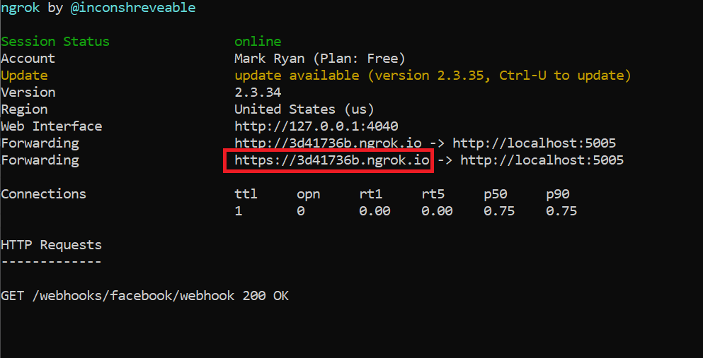
   * Get verify token from credentials.yml
   * Enter in edit callback dialog and click on Verify and Save
   * 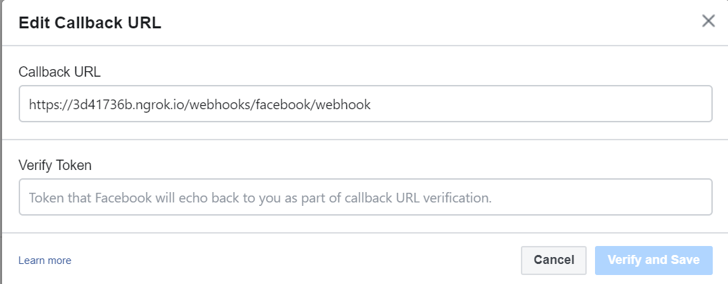
2. Start python:

& ".\rasa_run_actions.ps1"

1. Exercise chatbot:
   * Messenger app of desktop
   * Message **Karma AI Test**

**RUNNING TEST PROTOCOL:**

TEST PROTOCOL: following <https://forum.rasa.com/t/communicating-with-rasa-in-a-local-python-file/12068>

* 1. Test_client: batch on file defined in Python file
  2. Test_client_interactive: analyze issues
  3. Start Rasa with the following options – can use the script in c:\users\ryanm as shown below

rasa run -m models --endpoints endpoints.yml --port 5002 --credentials credentials_test.yml

& ".\rasa_run_tester.ps1"

* + - With restart of python server as well:

& ".\rasa_run_tester_python_run.ps1"

* 1. Start python
     + Rasa run actions
  2. In the main bot directory C:\personal\chatbot_july_2019\filebot_6 Invoke tester – first one is interactive so spot checking; second one is for reading from file

python test_client_interactive.py

python test_client.py > test_output.txt